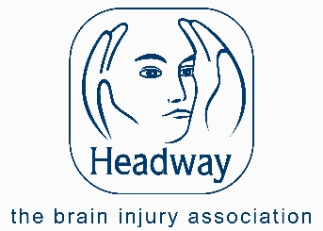
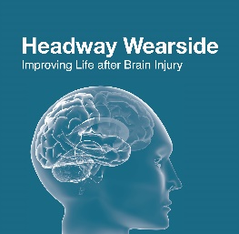
Headway Wearside:
Improving Life after Brain Injury
Charity Number 1140910 Company Number 07504702

Timetable

Our regular activities will continue on the dates below,
break for the summer and then continue September

4th July – Lunch club at Mickeys Place 12.30 pm
6th July – Social afternoon/Activity – Headway Wearside Activity Room, 1-3 pm
11th July – Lunch Club at Mickeys Place 12.30 pm
13th July – Exercise with DEB, bring your packed lunch.

Summer Activities

If you are interested in attending any of the activities you must reserve your place and pay any contributions by the booking deadline.

Date | Activity | Details
30th June | Hastings Hill Pub Lunch  12.30 pm | Meet at Hastings Hill Pub  Chester Road SR4 9LP.  Please bring money to pay for your meal and drinks
7 July | Afternoon Tea  1 pm | Headway Wearside Activity Room
14th July | Sunderland Glass Centre  10.15 am  Make a glass coaster  Glass blowing demonstration  Cuppa in café. | Book your Place by 7th June with Kim  Meet at Sunderland Glass Centre,  Liberty Way  SR6 0GL
21st July | Kurling/Games Day  1-3 pm | Headway Wearside Activity Room
4th August | Beamish Museum  Timeslot booked for 11am  Transport 10 am from Headway/Washington  Leave 4 pm . | Book Your Place by 14th July with Kim  £10 per person  You will need either packed lunch and or money for lunch/shopping.
18th August | Sunderland Museum and Winter Gardens  Cuppa and Catch up  10.30 am | Meet at the Museum,  Burdon Road SR1 1PP  Have a cuppa then a look around the museum

For further information contact Kim Hunter 0191 522 7113, www.headwaywearside.org.uk or call in at Headway Wearside. at St Mary & St Peters Community Project, Springwell Road, Sunderland SR3 4DY

